YARMOUK UNIVERSITY
Faculty of Information Technology and Computer Science | Department of Computer Information Systems
Online Retail II
Data Warehouse, Data Mining and Predictive Analytics
An end-to-end analytics project: ETL and data quality, star-schema warehouse in DuckDB, market basket analysis, RFM customer segmentation, next-month purchase and spend prediction, and an interactive Streamlit dashboard.
Prepared by Sara Mohammad Zreigat
Course Data Mining and Data Warehousing (DA 370)
Academic year 2025/2026
Dataset UCI Machine Learning Repository, Online Retail II (December 2009 to December 2011)
Tools Python, pandas, DuckDB, SQL, scikit-learn, mlxtend, Matplotlib, Plotly
Contents
1. Executive Summary 3
2. Introduction 4
2.1 Business context 4
2.2 Objectives 4
2.3 Dataset 4
3. Data Preparation and Quality 5
3.1 ETL rules 5
3.2 Validation 5
3.3 Exploratory findings 5
3.4 Anomalies 6
4. Data Warehouse Design 7
4.1 Dimensional model 7
4.2 Implementation 7
4.3 Analytical queries 8
5. Market Basket Analysis 9
5.1 Method 9
5.2 Results 9
6. Customer Segmentation 11
6.1 RFM features 11
6.2 Choosing the number of clusters 11
6.3 Segments 11
6.4 Action playbook 12
7. Predictive Modelling 13
7.1 Problem framing 13
7.2 Classification: will the customer buy next month? 13
7.3 Regression: how much will a returning customer spend? 14
7.4 Scoring the customer base 14
8. Interactive Dashboard 15
9. Business Recommendations 17
10. Limitations and Future Work 18
11. Conclusion 19
Appendix A. Project Files and Reproduction 20

1. Executive Summary
This report documents an end-to-end data warehousing and data mining project on the Online Retail II dataset: 779,425 cleaned invoice lines generated by 5,878 customers of a UK-based online giftware wholesaler between December 2009 and December 2011. The objective is to turn raw transactions into decisions: where revenue comes from, which products sell together, which customers deserve which treatment, and who is likely to buy next month.
The work is delivered as four executed Jupyter notebooks, an interactive seven-page HTML dashboard, this report and a presentation. A validated dataset feeds a star-schema warehouse in DuckDB, three data mining stages and the dashboard. Every number in this report is produced by the accompanying notebooks.
Table 1. Headline results
Area | Key result
Data quality | 10 of 10 automated checks pass; re-running the ETL on the processed data removes zero rows
Business performance | GBP 17.37M revenue from 36,969 orders; November is the peak month in both years
Concentration | Top 20% of customers generate 77% of revenue; the United Kingdom accounts for 82.8%
Data warehouse | 1 fact table and 4 dimensions; 7 analytical SQL queries, each answered in under 0.2 seconds
Market basket | 510 association rules; strongest product pairs reach lift 56 and confidence 89%
Segmentation | 4 segments; Champions are 19% of customers and 72% of revenue
Purchase prediction | Gradient Boosting, F1 0.526 and ROC-AUC 0.800 on five unseen months (naive rule F1 0.421)
Spend prediction | Random Forest, MAE GBP 387 and R-squared 0.47 (baseline R-squared 0.16)

Recommendation in one sentence
Protect the 1,117 Champions who produce most of the revenue, run model-ranked win-back campaigns for the 1,474 At Risk customers before the autumn peak, and convert the 1,231 Promising newcomers with 'complete the set' recommendations derived from the association rules.

2. Introduction

2.1 Business context
The retailer is a non-store online business that sells all-occasion giftware such as decorations, kitchenware, bags and stationery. Many of its customers are wholesalers who resell the products, which explains large order values, a strong weekday pattern and a very concentrated revenue base. The company operates in 41 countries, but the United Kingdom dominates sales.

2.2 Objectives

- Prepare a clean, validated, analysis-ready transaction dataset.
- Design and implement a dimensional data warehouse that answers performance questions quickly.
- Discover product affinities with association rule mining.
- Segment customers by behaviour and define an action plan for every segment.
- Predict next-month purchase behaviour and spend, and score the current customer base.
- Deliver the results through an interactive dashboard, this report and a presentation.

2.3 Dataset
The Online Retail II dataset is published by the UCI Machine Learning Repository under a CC BY 4.0 licence. The raw workbook contains two sheets (2009-2010 and 2010-2011) with one row per invoice line. After cleaning, each row carries the fifteen attributes summarised in Table 3.
Table 2. Attributes of the processed dataset
Attribute | Description
InvoiceNo | Six-digit invoice number; one invoice is one order
StockCode, Description | Product code and name
Quantity, UnitPrice | Units on the line and price per unit in GBP
TotalAmount | Derived revenue of the line: Quantity x UnitPrice
InvoiceDate | Timestamp of the invoice
DateKey, Year, Month, Day, Quarter, Hour | Derived calendar attributes for the time dimension
CustomerID, Country | Customer identifier and country

3. Data Preparation and Quality

3.1 ETL rules
The transformation is implemented once, in the function clean_raw_transactions, and applied in a fixed order. Every rule is logged with the number of rows it removes so that the process is auditable.
Table 3. ETL transformation rules
Step | Rule | Reason
1 | Merge both yearly sheets and standardise column names | Single consistent source table
2 | Trim text, upper-case stock codes, parse timestamps | Consistent keys and time arithmetic
3 | Drop lines without CustomerID or Description | Customer analysis needs an identified buyer
4 | Remove exact duplicate lines | Avoid double counting
5 | Remove cancelled invoices (prefix C) | Keep completed sales only
6 | Keep Quantity > 0 and UnitPrice > 0 | Remove returns, adjustments and free items
7 | Derive calendar keys and TotalAmount | Feed the time dimension and revenue measure

3.2 Validation
A separate validation function re-checks every rule together with the consistency of derived columns: no missing values, no duplicates, no cancellations, strictly positive quantities and prices, TotalAmount equal to Quantity x UnitPrice, and DateKey, Year and Quarter consistent with the timestamp. All ten checks pass, and the pipeline refuses to continue if any fails. As a further proof, the processed dataset was fed back through the full transformation: no rows were removed and the output matched the input, so the shipped dataset is a fixed point of the ETL.

3.3 Exploratory findings
Revenue follows a pronounced annual cycle. It is stable at around GBP 0.5M to 0.7M per month in the first half of each year, then climbs from September to a November peak of GBP 1.17M in 2010 and GBP 1.16M in 2011 as customers stock up for Christmas. December 2011 covers only nine days and must not be read as a decline.
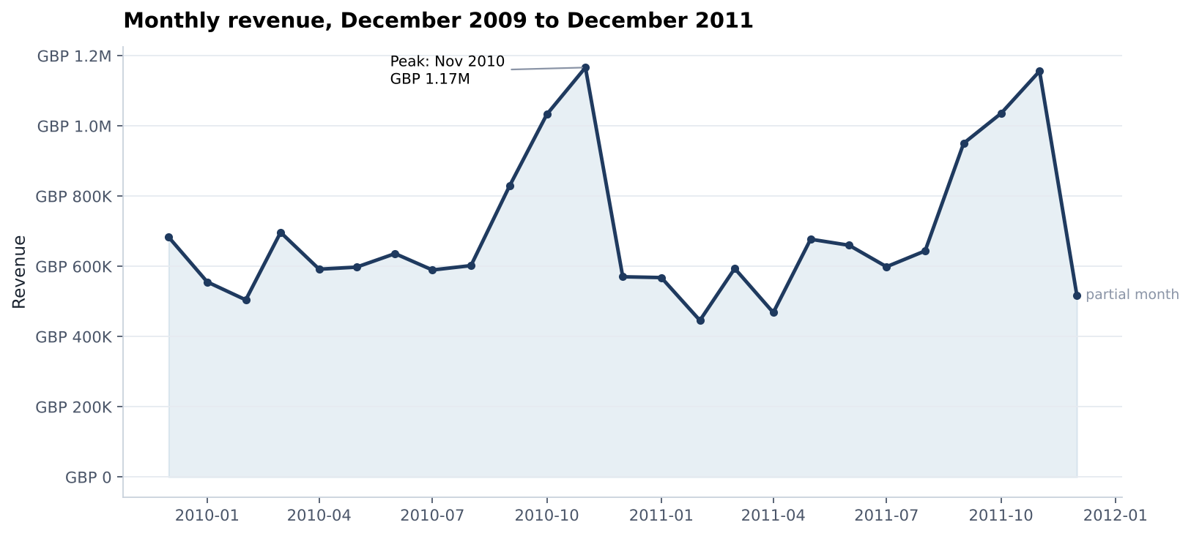
Figure 1. Monthly revenue, December 2009 to December 2011
Revenue is highly concentrated. The top 20% of customers account for 77% of revenue and the top 1% alone for 32%, while 28% of customers ordered only once. The median order is worth GBP 303 and contains 15 different lines. Orders arrive almost exclusively on weekdays between 10:00 and 15:00, and there is virtually no Saturday trade, which is consistent with business buyers.
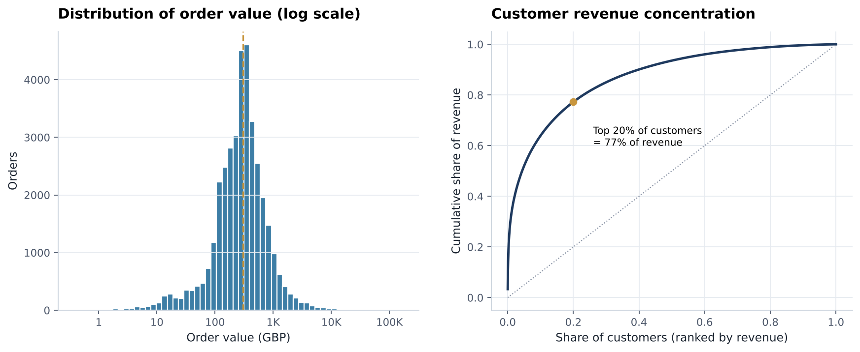
Figure 2. Order value distribution (left) and customer revenue concentration (right)

3.4 Anomalies
Two lines dominate the extremes: 80,995 units of PAPER CRAFT, LITTLE BIRDIE (GBP 168,470) and 74,215 units of MEDIUM CERAMIC TOP STORAGE JAR (GBP 77,184). In the raw source each was reversed by a same-day cancellation, which the cleaning rules remove, so the original lines remain. They are retained to keep the dataset faithful to the documented ETL, and the analysis is designed to be robust to them through log transforms, median statistics and MAE-based model selection. Postage, carriage, manual adjustments and test codes are kept in revenue totals but excluded from product-level analysis.

4. Data Warehouse Design

4.1 Dimensional model
The warehouse follows Kimball dimensional modelling. The business process is retail sales, and the grain of the fact table is the invoice line, the lowest level available, so any roll-up remains possible.
Table 4. Dimensional design decisions
Design decision | Choice
Grain | One row per invoice line (779,425 rows)
Measures | Quantity and TotalAmount (additive), UnitPrice (non-additive), InvoiceHour
Dimensions | Date (739 days), Customer (5,878), Product (4,631), Location (41)
Keys | Integer surrogate keys; DateKey as a YYYYMMDD smart key
Degenerate dimension | InvoiceNo stored on the fact table to count orders
Product history | 599 stock codes changed description; the most frequent description is kept
Multi-country customers | Location is attached to each sale; the customer keeps a primary country

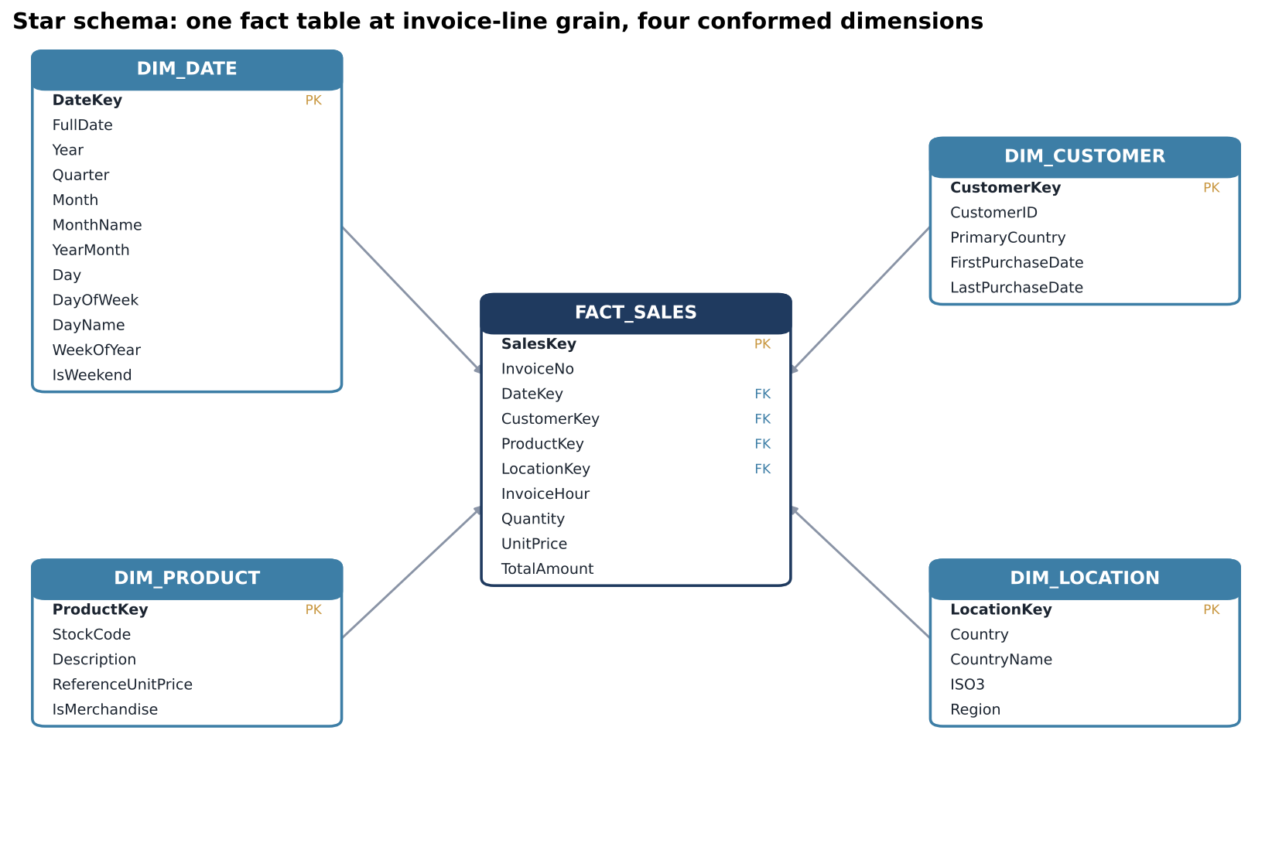
Figure 3. Star schema of the Online Retail II warehouse

4.2 Implementation
The physical warehouse is built in DuckDB, an embedded columnar OLAP engine that requires no server. The DDL script declares primary keys, foreign keys and check constraints, and a separate index script creates indexes on every fact foreign key and on frequently filtered attributes. Tables are loaded in dependency order. Integrity checks confirm that every foreign key resolves and that revenue in the fact table reconciles exactly with the source (GBP 17,374,804.27).

4.3 Analytical queries
Table 5. Analytical query workload and median execution time on the full fact table (development laptop, 5 runs)
Query | Business question | Median time
revenue_by_country | Revenue, orders, customers and share by country and region | 33 ms
monthly_sales_trend | Monthly revenue with month-over-month and year-over-year growth | 36 ms
top_products_by_revenue | Ten highest-revenue merchandise products | 134 ms
repeat_customer_value | Lifetime value of customers with more than five orders | 35 ms
sales_by_weekday_hour | Order activity by weekday and hour | 35 ms
quarterly_rollup | Revenue with year and quarter subtotals (GROUP BY ROLLUP) | 35 ms
customer_cohort_retention | Share of each monthly cohort active N months later | 24 ms

The queries show that the 1,801 customers with more than five orders, 31% of the base, generate 80.1% of revenue. Year-over-year, 2011 tracked 2010 closely, which indicates a stable but flat business. The cohort query reveals the most important structural weakness: after the first month, typically fewer than a quarter of newly acquired customers buy again in any given month.
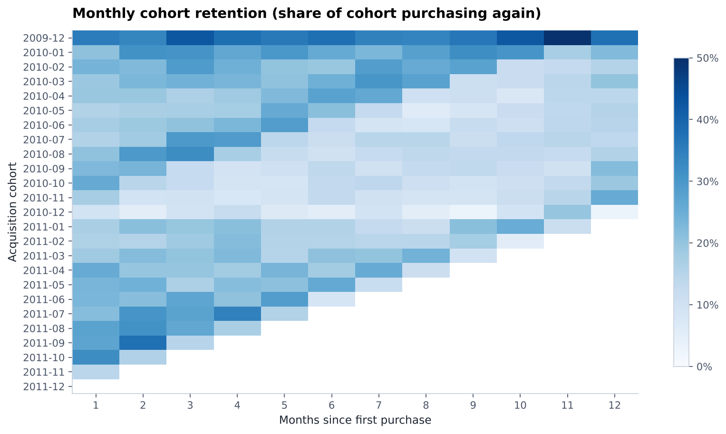
Figure 4. Monthly cohort retention

5. Market Basket Analysis

5.1 Method
Association rules were mined with the Apriori algorithm on United Kingdom invoices, which represent about 91% of orders; mixing markets with different assortments would dilute country-specific affinities. Postage and fee codes were removed, and products were keyed by stock code. The resulting boolean matrix has 33,361 invoices and 4,605 products. Itemsets had to appear on at least 1% of invoices, and rules were kept when confidence was at least 30% and lift greater than 1.

5.2 Results
Apriori found 860 frequent itemsets (552 single items, 256 pairs and 52 triples) and 510 rules. The most frequent single product is the WHITE HANGING HEART T-LIGHT HOLDER, present on 14% of UK invoices. The strongest rules connect members of the same product family, as Table 7 shows.
Table 6. Strongest association rules (one rule per product pair)
If a customer buys | They also buy | Confidence | Lift
Poppy's Playhouse Livingroom | Poppy's Playhouse Kitchen | 89% | 56.1
Poppy's Playhouse Bedroom | Poppy's Playhouse Kitchen | 85% | 53.6
Set/6 Red Spotty Paper Plates | Set/6 Red Spotty Paper Cups | 66% | 50.5
Set/10 Pink Spotty Party Candles | Set/10 Blue Spotty Party Candles | 64% | 44.1
Wooden Tree Christmas Scandinavian | Wooden Star Christmas Scandinavian | 80% | 43.6
Key Fob, Garage Design | Key Fob, Shed | 78% | 40.5
Red Stripe Ceramic Drawer Knob | Blue Stripe Ceramic Drawer Knob | 67% | 38.5

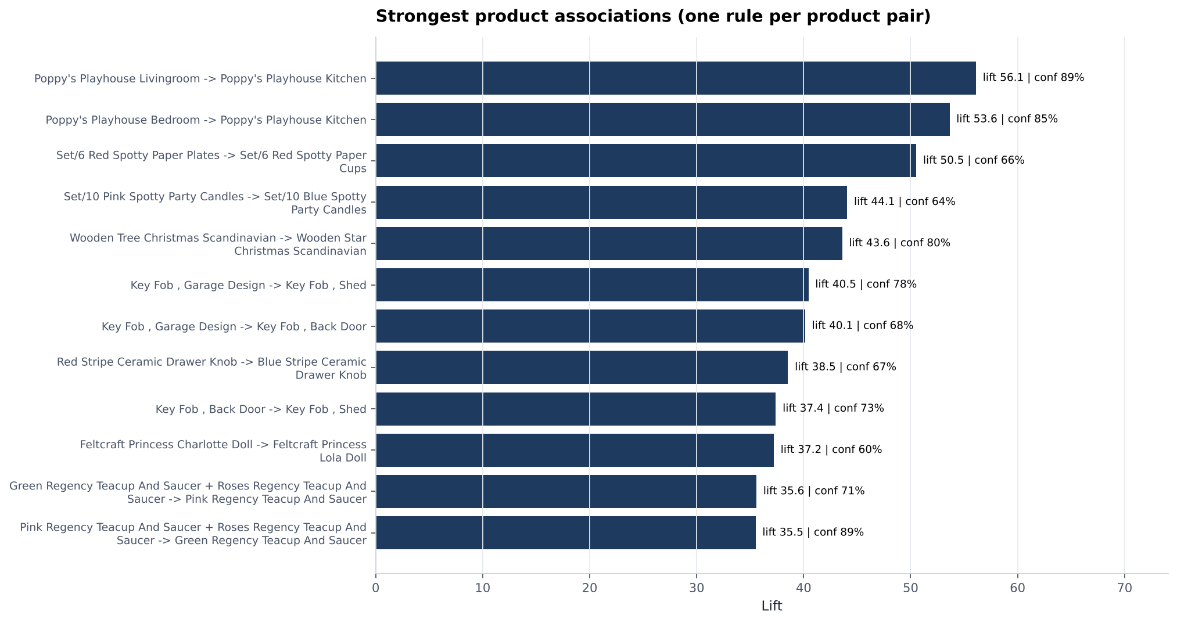
Figure 5. Strongest product associations by lift
Business use
Customers clearly collect sets: playhouse rooms, matching party tableware, Christmas decorations, key fobs and teacups in several colours. The rules support 'complete the set' recommendations on product pages and at checkout, pre-built bundles, and placing family members next to each other in catalogues and on the website.

6. Customer Segmentation

6.1 RFM features
Each customer is described by Recency (days since the last order, measured from 10 December 2011), Frequency (number of distinct orders) and Monetary value (total spend). The three variables are extremely right-skewed: the median customer spent GBP 868 while the largest spent GBP 580,987. K-Means minimises squared distances, so on raw values it isolates a handful of very large customers instead of finding behavioural groups. The features were therefore log-transformed and then standardised.

6.2 Choosing the number of clusters
Values of k from 2 to 8 were compared using the elbow method and three internal validity indices. Two clusters give the highest silhouette but are too coarse for marketing, so the best silhouette among solutions with at least three segments was selected: k = 4 (silhouette 0.365, Davies-Bouldin 0.94).
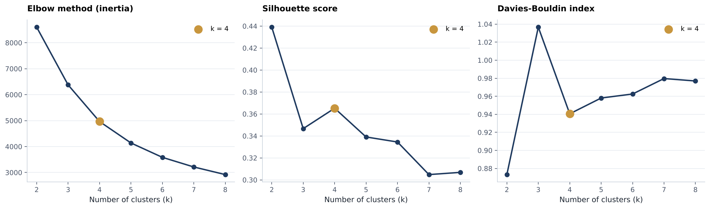
Figure 6. Elbow, silhouette and Davies-Bouldin criteria for k = 2 to 8

6.3 Segments
Clusters are named deterministically from their centroids: the strongest combination of frequency, spend and recency becomes Champions, and the remaining clusters are ordered by recency.
Table 7. Customer segment profiles
Segment | Customers | Share of revenue | Median recency | Avg orders | Median spend
Champions | 1,117 (19%) | 72.1% | 15 days | 20.0 | GBP 5,232
Promising | 1,231 (21%) | 5.9% | 23 days | 3.0 | GBP 721
At Risk | 1,474 (25%) | 17.9% | 162 days | 5.4 | GBP 1,587
Hibernating | 2,056 (35%) | 4.0% | 400 days | 1.4 | GBP 291

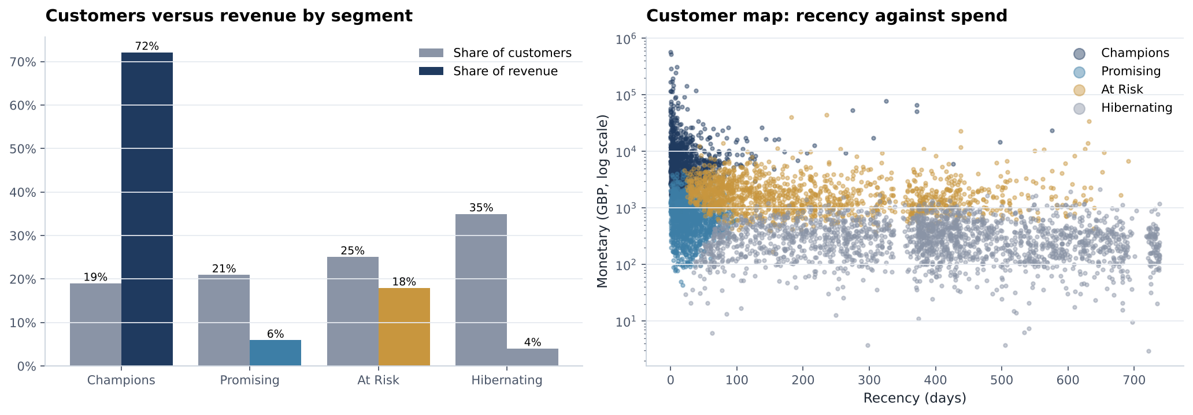
Figure 7. Customer and revenue share by segment (left) and the customer map (right)

6.4 Action playbook
Table 8. Segment action playbook
Segment | Recommended action
Champions | Protect with VIP loyalty tiers, early access to new ranges, dedicated account management and volume pricing.
Promising | Nurture with onboarding journeys, second-order incentives and cross-sell recommendations from the association rules.
At Risk | Prioritise personalised win-back campaigns, reminders of previously bought items and time-limited offers.
Hibernating | Re-engage through low-cost automated email only; exclude from expensive paid campaigns.

7. Predictive Modelling

7.1 Problem framing
At the end of every month a snapshot of all known customers is taken. Thirteen features describe behaviour up to that date only: recency, frequency, monetary value, average order value, units, distinct products, tenure, active months, orders and spend in the previous 90 days, activity in the snapshot month, and the calendar month being predicted (to capture seasonality). Two targets describe the following month: whether the customer orders at all (classification, 22% positive) and how much a purchasing customer spends (regression).
Leakage is controlled in three ways. Features never use transactions after the snapshot date. Training and testing are split chronologically: snapshots from December 2009 to May 2011 (18 months) for training and June to October 2011 (5 months) for testing. Finally, the November 2011 snapshot is excluded from evaluation because its target month is only partially observed; it is used only to score the current customer base.

7.2 Classification: will the customer buy next month?
Three models were compared with a naive business rule that predicts a purchase for every customer who bought in the current month. Class weights compensate for the imbalance, and each model's decision threshold was tuned to maximise F1 on the last three training months before refitting on the full training period.
Table 9. Classification results on the five test months
Model | Precision | Recall | F1 | ROC-AUC | PR-AUC
Naive rule (bought this month) | 0.416 | 0.426 | 0.421 | - | -
Logistic Regression | 0.445 | 0.630 | 0.521 | 0.798 | 0.560
Random Forest | 0.487 | 0.554 | 0.519 | 0.797 | 0.562
Gradient Boosting (selected) | 0.476 | 0.587 | 0.526 | 0.800 | 0.562

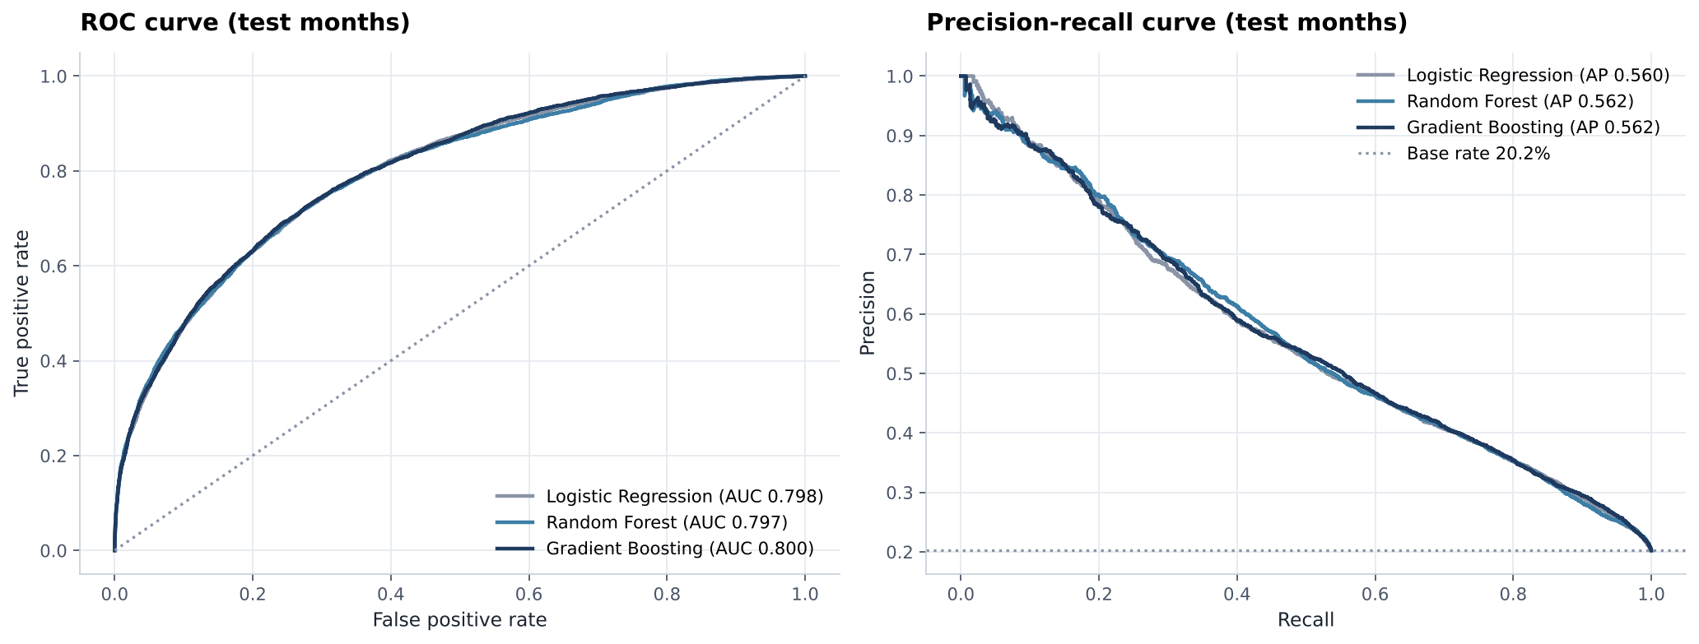
Figure 8. ROC and precision-recall curves on the test months
All models clearly beat the naive rule, and the three learners perform within 0.007 F1 of each other, which shows that purchase timing is driven by a few strong, largely monotonic signals. Permutation importance confirms that recency is by far the most influential feature, followed by frequency, active months, tenure and the target month. In practice, ranking customers by predicted probability is very efficient: the top decile buys at 3.3 times the average rate and the top 20% of customers capture 52% of all next-month buyers.

7.3 Regression: how much will a returning customer spend?
Spend was modelled for customers who do purchase, on a log scale because of its heavy right skew, and predictions were converted back to GBP for evaluation. Mean absolute error was used to select the model because a few very large wholesale orders would dominate squared-error metrics.
Table 10. Regression results on the five test months
Model | MAE (GBP) | Median AE (GBP) | RMSE (GBP) | R-squared
Baseline (historical average order value) | 450.6 | 134.8 | 2,083.4 | 0.158
Ridge Regression | 399.9 | 139.4 | 1,832.0 | 0.349
Random Forest (selected) | 386.9 | 139.1 | 1,652.0 | 0.471
Gradient Boosting | 392.3 | 136.7 | 1,773.7 | 0.390

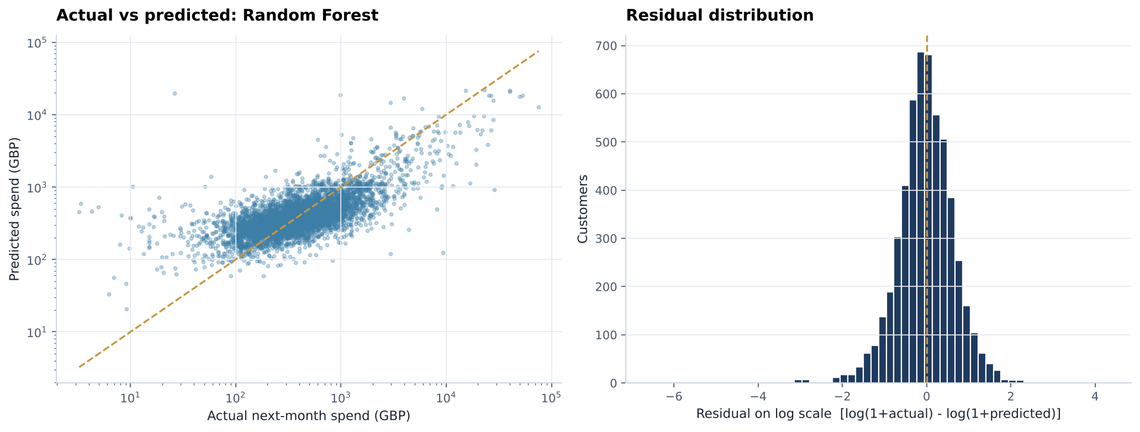
Figure 9. Actual against predicted spend (log scale) and residual distribution
Random Forest reduces MAE by 14% against the baseline and triples the explained variance, from R-squared 0.16 to 0.47. Historical average order value and spend in the previous 90 days are the dominant drivers. About 63% of predictions fall within plus or minus 50% of actual spend; individual amounts remain uncertain for the largest wholesale orders, so the model is best used to rank customers by expected value.

7.4 Scoring the customer base
The selected models score all 5,850 customers known at the end of November 2011. Each customer receives a purchase probability, a predicted spend if they buy, and a priority score (probability multiplied by predicted spend) used to order outreach. 1,189 customers are flagged as likely buyers, of whom 810 are Champions and 279 are At Risk, which gives the marketing team a concrete, prioritised target list.

8. Interactive Dashboard
The results are delivered through a seven-page interactive dashboard packaged as a single HTML file. It opens in any web browser with a double click, needs no installation or internet connection, and offers year and country filters, interactive Plotly charts with hover details, a rule explorer, a product recommender, a ranked list of customers to contact next month, and a light and dark theme.
Table 11. Dashboard pages
Page | Content
Executive Overview | KPIs, monthly revenue and orders, top products and international markets
Sales Trends | Year-over-year monthly revenue, weekday and hour heat map, quarterly summary
Geography | World revenue map, revenue by region, country league table
Customer Segments | Segment KPIs, share of customers and revenue, choice of k, customer map, playbook, cohort retention
Market Basket | Rule explorer with filters and search, strongest associations, product recommender
Predictive Models | Model comparison, ROC curves, feature importance, result tables, customers to contact next month
Data Quality and Warehouse | Quality checks, dataset profile, star schema, referential integrity, query benchmarks

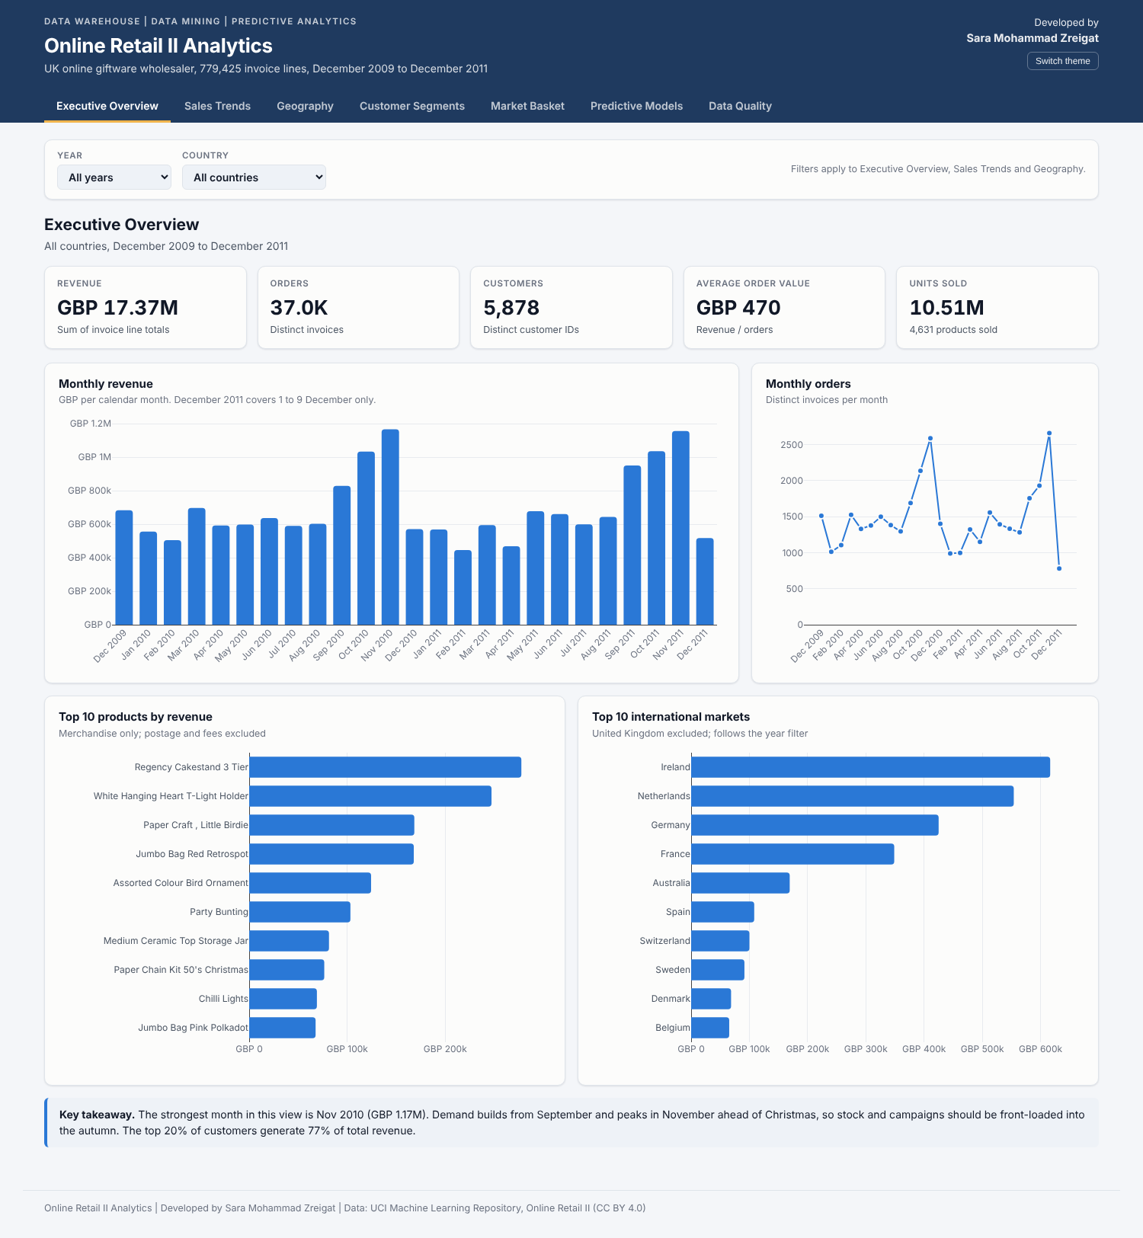
Figure 10. Executive Overview page of the dashboard

9. Business Recommendations

- Protect the Champions. 1,117 customers generate 72% of revenue. Introduce a VIP programme with account management, early access to autumn ranges and volume pricing; monitor their recency weekly, since recency is the strongest predictor of purchase.
- Win back At Risk customers before the peak. 1,474 previously valuable customers have been silent for a median of 162 days. Use the propensity scores to target those with the highest priority score in September and October, when demand is building.
- Convert newcomers. Cohort retention after the first month is low. Give Promising customers a structured second-order journey with recommendations drawn from the association rules.
- Sell complete sets. Rules with lifts above 40 show that customers buy product families together. Bundle variants, add 'complete the set' prompts at checkout and group families in catalogues.
- Plan for seasonality. Front-load stock, staffing and campaigns into September to November, when monthly revenue nearly doubles.
- Grow high-value export accounts. Markets such as the Netherlands, Australia and Ireland combine few customers with very high order values and merit dedicated wholesale account management.

10. Limitations and Future Work
- The data contains purchasing history only. Prices, promotions, stock availability and customer firmographics, which also drive behaviour, are not available.
- Only one full seasonal cycle precedes the test period, so seasonal effects are learned from a single year.
- Classifier probabilities are not calibrated because of class weighting; they should be calibrated, for example with isotonic regression, before being used as revenue forecasts.
- Association rules cover United Kingdom invoices; country-specific rule sets would serve international markets better.
- Future work: customer lifetime value models (BG/NBD and Gamma-Gamma), product-category hierarchies for the product dimension, scheduled incremental loads into the warehouse, and A/B testing of the recommended campaigns.

11. Conclusion
The project shows how a single, well-governed dataset can support every level of analytics. A validated ETL and a star-schema warehouse provide fast, trustworthy reporting; association rules reveal that customers buy product families as sets; RFM clustering shows that a fifth of customers carry nearly three quarters of revenue; and leakage-free predictive models identify, a month in advance, which customers will buy and how valuable they are likely to be. Delivered through executed notebooks and an interactive dashboard, these results translate directly into a prioritised commercial plan built around retention, win-back, cross-selling and seasonal readiness.

Appendix A. Project Files and Reproduction
The project is delivered as separate files. To view or reproduce the results:

- Dashboard: double-click Online_Retail_Dashboard.html; it opens in any web browser without installation.
- Notebooks: open each .ipynb file in Google Colab (File, Upload notebook) or Jupyter. All outputs are already saved inside them.
- To re-run a notebook, place Online_Retail_II_Cleaned.csv next to it (or upload it when Colab asks) and choose Run all.
- Run the notebooks in order, 01 to 04: data quality, data warehouse, unsupervised mining, predictive modelling.
All random processes use a fixed seed (random_state = 42), so results are identical between runs.
Table 12. Technology stack
Layer | Technology
Data processing | Python 3, pandas, NumPy
Data warehouse | DuckDB, SQL (DDL, window functions, ROLLUP)
Data mining | mlxtend (Apriori), scikit-learn (K-Means, Logistic Regression, Random Forest, Gradient Boosting, Ridge)
Visualisation | Matplotlib (notebooks and report), Plotly (dashboard)
Dashboard | Self-contained HTML with Plotly.js (works offline)
Quality | Automated data-quality checks and referential-integrity tests

